Tên: Nguyễn An Phúc – MSV: 21IT639 - 21NS

Lab 8: Managing Files and Directories

8.2 Globbing

8.2.1 Step 1
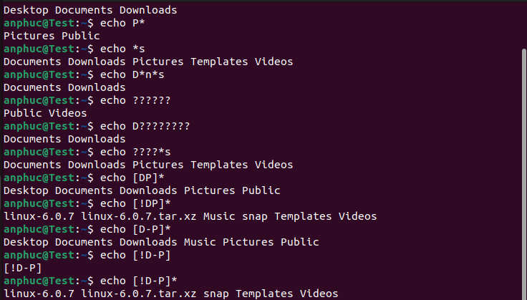

8.3 Copying, Moving and Renaming Files and Directories

8.3.1 Step 1

ls
cp /etc/hosts hosts
ls

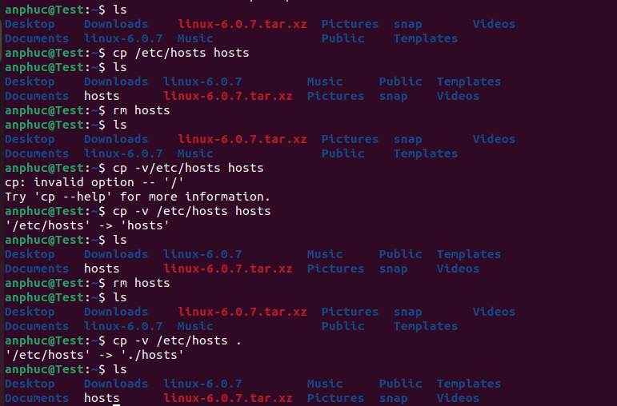

8.3.2 Step 2
Next, you will remove the file, then copy it again, but have the system tell you what is being done. This can be achieved using the -v or --verbose option. Enter the following commands:
rm hosts
ls
cp –v /etc/hosts hosts
ls

8.3.3 Step 3
Enter the following commands to copy the /etc/hosts file, using the period . character to indicate the current directory as the target:
rm hosts
ls
cp –v /etc/hosts .
ls
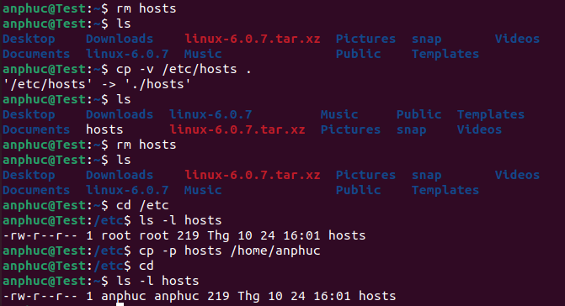

8.3.4 Step 4
Enter the following commands to copy from the source directory and preserve file attributes by using the -p option:
rm hosts
ls
cd /etc
ls -l hosts
cp –p hosts /home/sysadmin
cd
ls –l hosts

8.3.5 Step 5
Type the following commands to copy using a different target name:
rm hosts
cp -p /etc/hosts ~
cp hosts newname
ls –l hosts newname
rm hosts newname

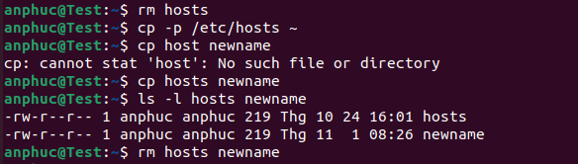

8.3.6 Step 6
To copy all files in a directory, use the -R option. For this task, we will copy the /etc/udev directory into a new directory and display the contents that were copied there. Naturally, the directory must be created before files can be added to it. In this example we will use the default settings for mkdir to create the “Myetc” directory. Options are available for the mkdir command to set security, permissions and other attributes of a new directory. Once the directory has been copied, the ls command is used to list the contents of the directory with both the long and recursive options.
mkdir Myetc
cp –R /etc/udev Myetc
ls –l Myetc
ls –lR Myetc

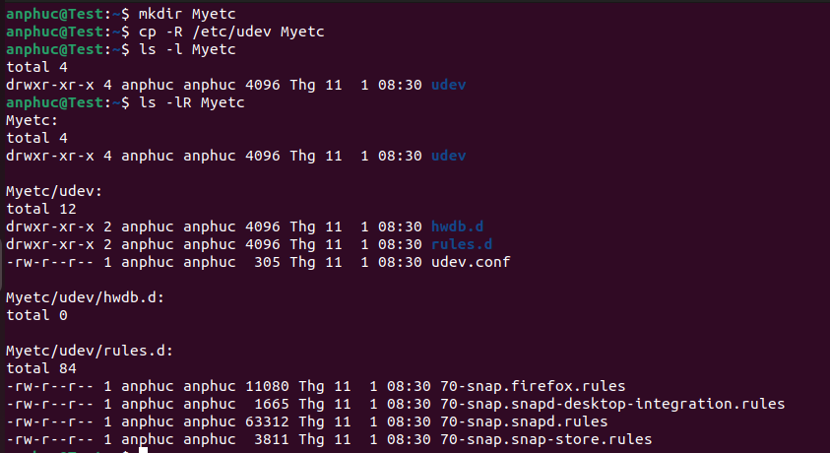

8.3.7 Step 7
To remove a directory, use the -r option to the rm command:
ls
rm -r Myetc
ls
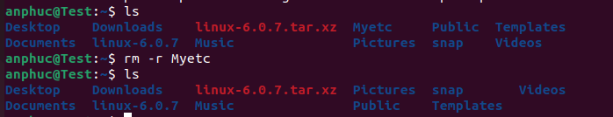

8.3.8 Step 8
Moving a file is analogous to a "cut and paste". The file is “cut” (removed) from the original location and “pasted” to the specified destination. Move a file in the local directory by executing the following commands:
touch premove
ls
mv premove postmove
ls
